# 读后续写背诵素材

# 人物描写(外貌特征、个性品格)

# 

目录

**第一部分 素材积累**

**第二部分 练习与参考答案**

# Part 1 表示人物体型

1. 优美的身段：a graceful figure

2. 匀称的形体：a shapely figure

3. 痩削的身材：a skinny figure

4. 细长的身体：a slim figure

5. 发育良好的身体：a well-developed figure

6. 仪表堂堂：an imposing/a dashing/a handsome/a

7. (人)形体很好：have a good figure

8. 改善形体：improve one ’s figure

9. 看到月光下有一个模糊的人影：see a dark figure in the moonlight

10. 显露出她优美的身段：show off her lovely figure

11. 中等身材：an average build

12. 身材魁梧的人：a well-built man

# Part 2 表示个性品格

1. 务实的：be down-to-earth

2. 脱颖而出：stand out from the crowd

3. 保守的性格：conservative personalities

4. 缺乏责任感：lack of responsibility

5. 具有...的美德：with the virtue of

6. 责任感：sense of responsibility

7. —个专心致志进行探索的科学家：a scientist bent on making a discovery

8. 高素质、有经验的老师：highly qualified, well-experienced teaching staff

9. 光明的前途：promising future

10. 关于...很无知：be ignorant about

11. 具有对教学过程敏锐的洞察力：armed/equipped with a keen insight into the teaching process

12. —夜成名的人：an overnight successful person/an instant successful person

13. 生在城市，长在城市：city born and city bred

14. 脾气好的人：a good-humored/good natured person

15. 完人：a faultless/perfect person

16. 知名人士： a notable personage

17. —个从事专门职业的人：a professional person

18. 一个有自制力的人：a self-possessed person

19. 一个疑心重的人：a suspicious person

20. 天资高的人：a talented person

21. 有抱负的人：an ambitious person

22. 留胡须的人：a bearded man

23. 聪明人：an intellectual person

24. 个性强的人：a man of fine personality

25. 个性迷人的女人：a woman of engaging/fascinating

26. 有突出的个性：have striking personalities

27. 温和可爱的个性：lovable and good natured

28. 容易相处的人：an easy person to deal with

29. 冷酷无情的人：a cold-blooded man

30. 成年人：a full-grown man

31. 性情和善的男子：a good-natured man

32. 心肠冷酷的人：a hard-hearted man

33. 有前途的青年：a promising young man

34. 严肃的年轻人：a serious young man

35. 头脑简单的人：a simple-minded man

36. 能说会道的人：a smooth-spoken man

37. 消息灵通/见多识广的人：a well-informed man

38. 娴静有礼的淑女：a quiet, gracious lady

39. 说话直率的人：an out-spoken man

40. 有教养的女子：a cultured woman

41. 相貌平平的女人：a homely woman

42. 单身女人：a single woman

43. 丑女人：an ugly woman

44. 未婚妇女：an unmarried woman

45. 时髦的社交界妇女：a fashionable lady

46. 无辜/无邪的人：an innocent man

47. 一位多才多艺的女子：an accomplished young

48. 岁出头的姑娘：a girl in her early twenties

49. 动人的姑娘：an attractive girl

50. 浪漫的人：a romantic figure

51. 没有头脑的少女：an empty-headed girl

52. 著名人物：a well-known /prominent figure

53. 品格纯洁无瑕的女子：a girl of stainless character

54. 伟大的历史人物：a great historical character

55. 品格正直的人：a man of upright character

56. 没有出息的人：a worthless character

57. 具有独立的性格：possess an independent character

58. 有诚实的好名声：have an excellent character for honesty

59. 性格果断：be of a determined character

60. 乐观和有抱负的：be optimistic and ambitious

# Part 3 表示人物日常活动

1. 常常发生的事：a frequent occurrence

2. 费时的：time-consuming

3. 让某人记忆犹新：remain fresh in one ’ s memory

4. 一件身心有益的事情:an enchanting mental and physical business

5. 省钱省时间：be less time-consuming and more economical

6. 辛劳的任务：an arduous/a painstaking/a laborious task

7. 需要紧急处理：require urgent attention

8. 值得珍藏的经历：a truly memorable experience

9. 回忆高中生活的美好时刻：recall the sweet moment of one's high school life

10. 经受起起落落：go through ups and downs

11. 自动电话：a dial/an automatic telephone

12. 长途电话：a long-distance telephone

13. 在会上发表演讲：address a meeting

14. 有某人的电话：be wanted on the phone

15. 叫某人接电话：get sb. on the phone

16. 接通电话：get through

17. 拿起听筒：pick up the phone

18. 跟某人通电话：speak to sb. over the phone

19. 占线：the line is busy/the number is engaged

20. 盖过邮戳的邮票：a used stamp

21. 通知某人...:inform sb. Of sth.

## 外貌特征【牛刀小试】

**一、根据要求写出单词的正确形式。**

1.rough(反义词) 2.pety(反义词)

3.fat(反义词) 4.strong(反义词)

5. loose(反义词) 6.casual(反义词)

7. light(反义词) 8.common(近义词)

9.simple(近义词) 10.look (近义词)

11.serious(近义词) 12.good-looking(近义词)

1. **根据汉语意思将上下两行词结合为合成词(部分单词可以重复使用)。**

dark,long, red, ordinary, round,untidy, well, wide build, dress, eye,face,hair,leg,look, skin,sleeve

1.长腿的 2.穿着讲究的

3.红头发的 4.相貌平平的

6.体格健美的 5.看起来不整洁的

8.圆脸的 7.皮肤黝黑的

9.长袖的 10.睁大眼睛的

1. **根据图片写出对应的有关外貌特征的单词。**

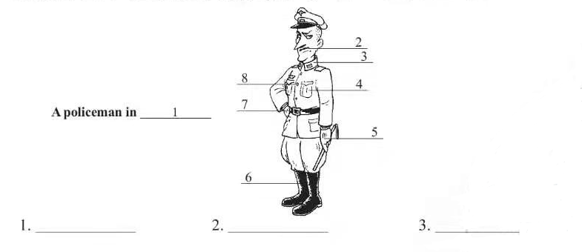

**外貌特征【参考答案】**

一、1.smooth 2.ugly 3.thin/slim 4.weak5.tight

1. formal 7.dark/heavy 8.ordinary 9.plain 10.appearance/expression

11.severe 12.beautiful/pretty /handsome/attractive

二、1.long-legged 2.wel-dressed 3.red-haired

4.ordinary-looking 5.untidy-ooking 6.well built 7.dark-skined

8.round-faced 9,long-sleeved 10.wide-eyed

三、1.uniform 2.moustache 3.collar 4.pocket

5.glove 6.boot 7.belt 8.button

## 性格与行为特征【牛刀小试】

一、根据所给汉语，写出英语单词。

1.勇敢的 2.明智的

3.健忘的 4.礼貌的

5.粗鲁的 6.温和的

7.沉默的 8.诚实的

9.谦虚的 10.自私的

11.愚蠢的 12.直率的

13.有天赋的 14.幽默的

15.体贴的

二、写出下列单词的反义词。

1. pessimistic 2. negative

3. mean 4. vice

5. dependent

三、根据所给汉语，写出单词的正确形式。

1. He has a cheerful but quiet_________(性格).

2. Mary has the (品质)of honesty and generosity.

3. People with a positive (态度) to life are admirable.

4.TV violence may cause aggressive (行为).

5.He was known to be a man of great (智慧).

6.You must try to be a little more (实际的).

7. We are looking for someone who is (可靠的)and hard-working.

8. You need to be more_____(灵活的)and imaginative in your approach.

9. It was (慷慨的)of him to offer to pay for us both.

10. John is a(n)_______(善解人意的and intelligent young man.

11. She is over eighty，but is till_____(活跃的).

12.He was too (偏强的)to admit that he was wrong

13.Kate is very (严格的) with her students.

**性格与行为特征【参考答案】**

1.brave/couragecous 2.wise/sensible 3.forgetful 4.polite 5.rude 6.gentle 7.silent 8.honest 9.modest 10.selish 11.stupid/foolish/sily 12. direct/straight 13.gifed/talented 14.humorous 15.considerate / thoughtful

二、1.optimistic 2.positive 3.generous 4.virtue 5. independent

三、1.character 2.qualities 3.attitude 4.behaviour 5.wisdom 6.practical 7.reliable 8.flexible 9.generous 10.sensitive 11.active 12.subborn 13.strict